Name : yuvan shankar L
Reg.no: 192511072

CSA1509-Cloud computing and Big Data Analytics

EXPERIMENT 18:
Install Virtualbox/VMware Workstation with different flavours of linux or windows OS on top of your present windows environment.
Aim
To install VirtualBox and create a virtual machine with a different Linux or Windows operating system on the existing Windows environment.
Short Procedure
- Download and install Oracle VirtualBox on the Windows system.
- Download the ISO file of the required Linux/Windows OS.
- Open VirtualBox and select Create New Virtual Machine.
- Enter the VM name and select the downloaded ISO file.
- Allocate suitable RAM, CPU cores, and virtual hard-disk space.
- Start the virtual machine and follow the OS installation instructions.
- Complete the installation and restart the virtual machine.
- Verify that the newly installed OS runs successfully inside the virtual environment.

Step 1:- CREATING VM AND PROVIDING ISO FILE
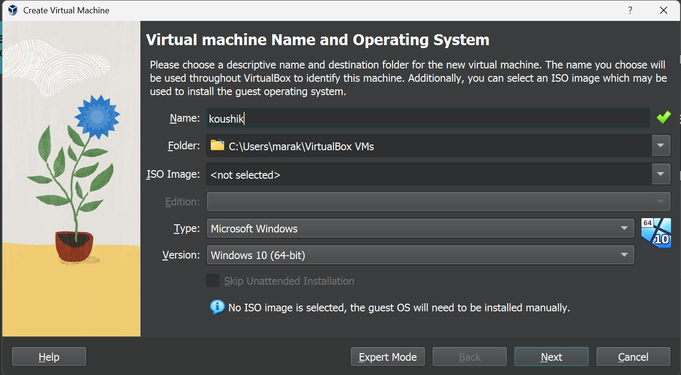

Step 2:- PROVIDING CREDENTIALS FOR THE VM

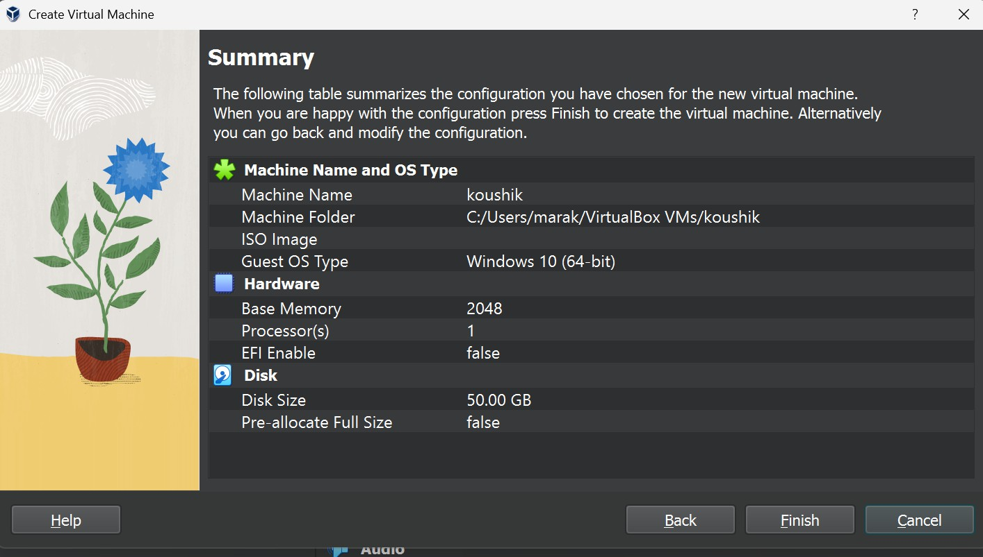

Step 4:-PROVIDING CREDENTIALS FOR THE VM
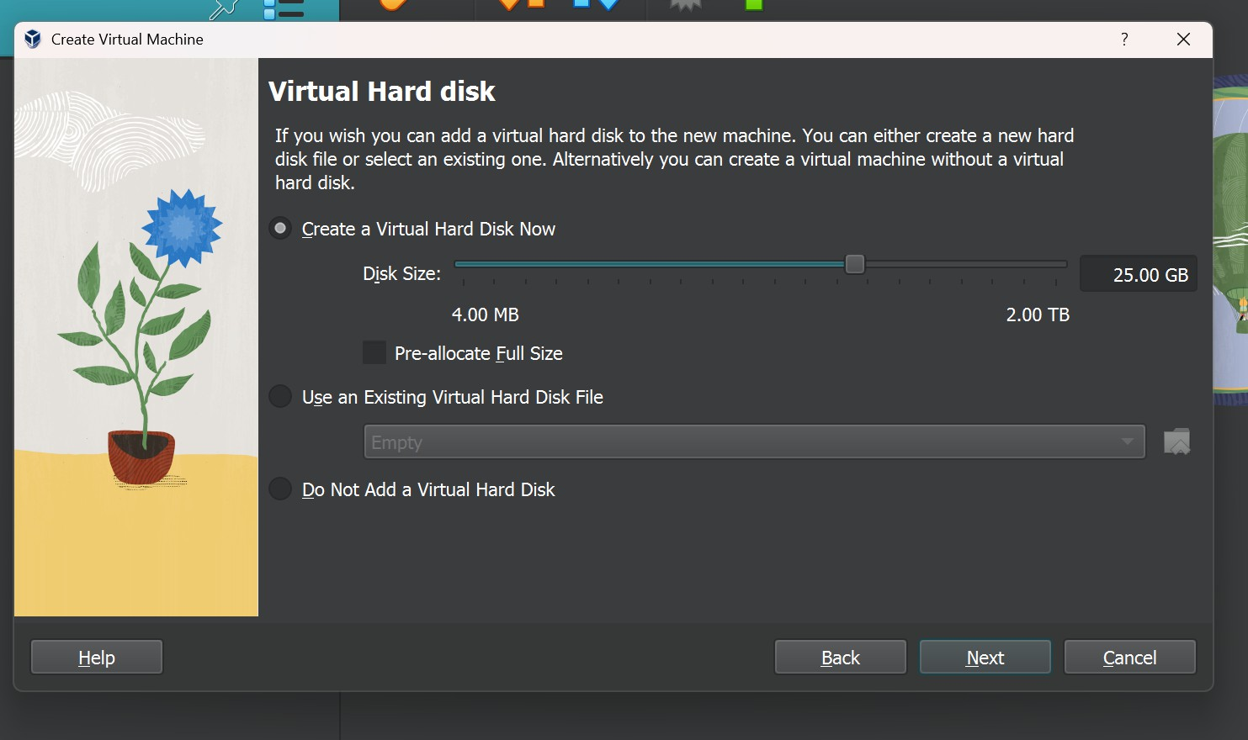

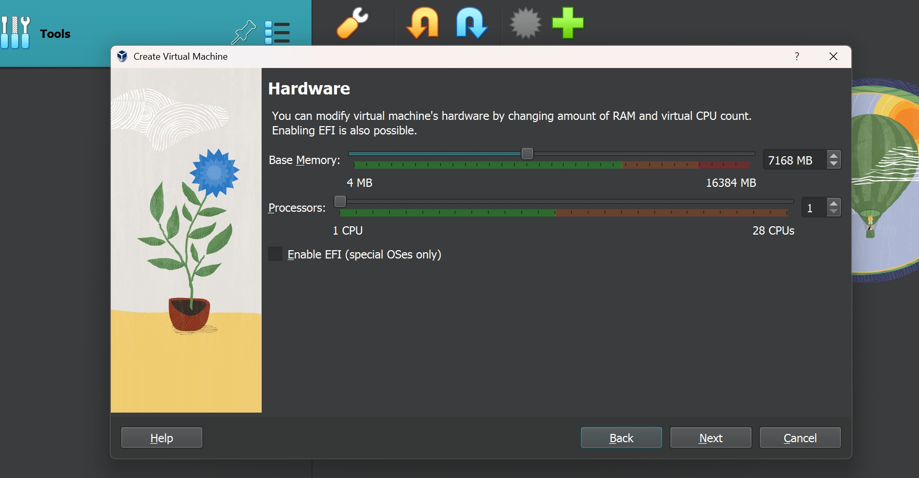
Step 5 : CREATING VIRTUAL HARD DISK WITH REQUIRED CONFIGURATION

Step 6 : CONFIGURING THE VM and

FIG : INSTALLATION OF VM IS FINISHED
